HTML Output:
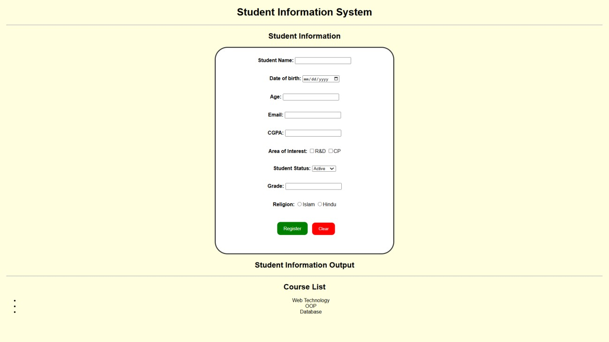
HTML Code:
<!DOCTYPE html
<html>
<head>
<title>Student Information System</title>
<link rel="stylesheet" href="style.css">
</head>
<body>

<h1>Student Information System</h1>

<hr>

<h2>Student Information</h2>

<form id="studentForm">

<div>
<label for="name">Student Name:</label>
<input type="text" id="name" required>
</div><br><br>
<div>
<label for="dob">Date of birth:</label>
<input type="date" id="dob" required>
</div><br><br>

<div>
<label for="age">Age:</label>
<input type="number" id="age" required>
</div><br><br>
<div>
<label for="email"> Email:</label>
<input type="email" id="email" required>
</div><br><br>

<div>
<label for="cgpa">CGPA:</label>
<input type="number" id="cgpa" required>
</div><br><br>

<div>
<label for = "interest">Area of Interest:</label>
<input type = "checkbox" name = "interest" value = "r&d">R&D
<input type = "checkbox" name = "interest" value = "cp">CP
</div><br><br>

<div>
<label for="status">Student Status:</label>
<select id="status">
<option value="Active">Active</option>
<option value="Inactive">Inactive</option>
</select>
</div><br><br>

<div>
<label for="grade">Grade:</label>
<input type="text" id="grade" required>
</div><br><br>
<div>
<label for="reli">Religion:</label>
<input type="radio", name="reli", value="Islam">Islam
<input type="radio", name="reli", value="Hindu">Hindu
</div><br><br>

<div>
<input type="submit" value="Register">
<input type="reset" value="Clear">
</div><br>

</form>

<h2>Student Information Output</h2>
<p id="studentOutput"></p>

<hr>

<h2>Course List</h2>

<ul align="center", id="courseList">
<li>Web Technology</li>
<li>OOP</li>
<li>Database</li>
</ul>

</body>
</html>

CSS Code:

title, body, h1, h2{
text-align: center;
}
body {
font-family: Arial, sans-serif; margin: 20px;
background-color: lightyellow;
}
label { font-weight: bold;
color: black;
}
form { width: 500px; max-width: 100%; margin: 20px auto; border: 3px solid #333; padding: 30px; background-color: white; border-radius: 40px;
}
button, input[type="submit"] { background-color: green; color: white; border: none; padding: 12px 20px; border-radius: 10px; cursor: pointer; font-size: 15px;
margin: 10px;
}
input[type="reset"] { background-color: red; color: white; border: none; padding: 12px 20px; border-radius: 10px;
cursor: pointer;
}
button:hover, input[type="submit"]:hover { background-color: darkgreen;
}

input[type="reset"]:hover {
background-color: darkred;
}
JavaScript Code:

let name = prompt("Enter student name:"); let age = Number(prompt("Enter student age:")); let cgpa = Number(prompt("Enter student CGPA:")); let status = prompt("Enter student status:");
let grade = prompt("Enter student grade:");

console.log("Student Information:"); console.log("Name:", name); console.log("Age:", age); console.log("CGPA:", cgpa); console.log("Status:", status);
console.log("Grade:", grade);

let courses = ["Web Technology", "OOP", "Database"];

console.log("Course Names:");

for (let i = 0; i < courses.length; i++) {
console.log(courses[i]);
}

let marks = Number(prompt("Enter student marks:")); let result;

if (marks >= 80) {
result = "A+";
}
else if (marks >= 70) {
result = "A";
}
else if (marks >= 60) {
result = "B";
}
else { result = "F";
}

console.log("Marks:", marks);
console.log("Calculated Grade:", result);

function showStudent(name, age) { console.log("Student Name:", name);
console.log("Student Age:", age);
}

showStudent(name, age);

let students = [];

for (let i = 0; i < 3; i++) {
students[i] = prompt("Enter student name " + (i + 1) + ":");
}

console.log("All Student Names:");

for (let i = 0; i < students.length; i++) {
console.log(students[i]);
}

